This exercise implements the two classes shown in the UML class diagram below.
Employee
refNo
forename
surname
dept
Employee(ref,sn,fn)
print()
getDeptName()
getManagersName()
setDept(d)
Department
deptName
manager
Department(n)
setManager(e)
getManagersName()
dept 

⧫ manager

The two associations between the classes (dept and manager) are such that an employee can only be in one department, and that each department has only one manager. These associations are implemented by giving Employee an attribute of class Department called dept. In a similar way the class Department has an attribute called manager, which of class Employee.

Here is the code to implement the Department and Employee classes:-

- public class Department
attribute manager
is of type Employee
- {
- String deptName;
- Employee manager;

- public Department(String in_deptName)
- {
- deptName = in_deptName;
- } // end constructor Department(deptName)

- public void setManager(Employee anEmployee)
- {
- manager = anEmployee;
- } // end method setManager

- public String getManagersName()
test for a non-existent
manager object
- {
- String managersName;
- if (manager == null)
- managersName = "*Unknown";
- else
- managersName = manager.forename+" "+manager.surname;
- return managersName;
access the attributes of
the manager object
- } // end method getManagersName

- } // end class Department
- public class Employee
- {
- int refNo;
attribute dept
is of type Department
- String forename;
- String surname;
- Department dept;

- public Employee(int in_refNo, String in_forename,
String in_surname)
- {
- refNo = in_refNo;
- forename = in_forename;
- surname = in_surname;
- } // end constructor Employee(refNo, forename, surname)

- public void setDept(Department theDept)
- {
- dept = theDept;
- } // end method setDept

- public String getDeptName()
- {
- String deptName;
- if (dept == null)
- deptName = "*Unknown";
- else
- deptName = dept.deptName;
- return deptName;
- } // end method getDeptName

- public String getManagersName()
invoke a method of
another class
- {
- String managersName;
- if (dept == null)
- managersName = "*Unknown";
- else
- managersName = dept.getManagersName();
- return managersName;
- } // end getManagersName

- public void print()
- {
- System.out.println("Ref: "+refNo);
- System.out.println("Name: "+forename+" "+surname);
- System.out.println("Dept: "+getDeptName());
- System.out.println("Manager: "+getManagersName());
- } // end method print()

- } // end class Employee

Notes

class Department

Line 4: The manager for a department is implemented as an attribute of class Employee. This is an object ID, not the actual name of the manager.

Line 6: This constructor has a parameter which allows the object’s state to be initialised when it is instantiated.

Line 11: This method takes a parameter of class Employee and uses it to set the association of the department object with its manager.

Line 16: This method is used to obtain the name of the department’s manager as a String. Since the attribute manager might point at null object , we need to test for this within the method to avoid a “Null Pointer” error.

class Employee

Lines 3-6: The attributes of this class include dept, which is of class Department. This associates the employee with his/her department.

Line 8: The constructor for this class takes three parameters that are used to initialise the object’s state.

Line 15: setDepartment( ) takes a parameter of class Department and allows us to associate this employee with his/her department by setting the value of the dept attribute.

Line 20: This method obtains the name of the department for this employee.

Line 30: This method obtains the name of this employee’s manager. Remember that the attribute dept is the object ID of this employee’s department. So by sending the getManagersName( ) message to the object dept we can obtain the manager of the department! The method needs to test for a null pointer to avoid an error.

Line 40: The print( ) method displays the employee details on the terminal window.

A. Create the two classes

1. Start a new BlueJ project called T2O_employee

2. Create new classes called Department and Employee

3. Enter the code for each class as shown on the previous page

4. Compile the classes and check for syntax errors
B. Create instances of each class

1. Create objects to represent the following two departments:-

d1 “Sales” d2 “Research”

2. Create the following employee objects:-

e1 100 “Fred” “Smith” e2 007 “Jane” “Bond” e3 666 “Nick” “Jones”

3. Right Click on object e1 and invoke the method setDept(d1).

4. Use the object inspector to examine the attributes of e1. Select the dept attribute (1) and click on the Inspect button (2). A new inspector window shows the attributes of the associated Department (3):-

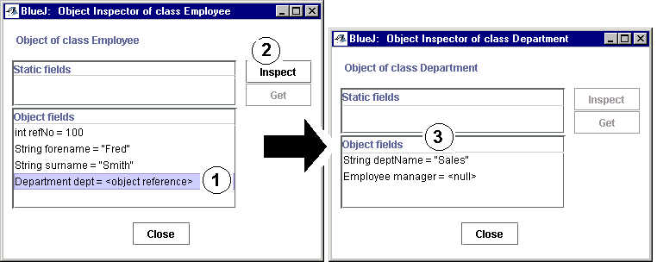

5. Use setDept( ) to make employee e2 a member of the Sales dept (d1).

6. Use the set Manager( ) method of d1 to make employee e2 its manager.

7. Use the object inspector to examine the attributes of employee e1, use the dept attribute to find the department (as in 4 above). Use the manager attribute to get the manager’s name.

8. Use the getManagersName( ) method of d1 to find the manager of this department.

9. Use the print( ) method to employee e3 to obtain his full details.

10. Add your own details in a new employee. Make yourself an member of the Research dept and also its manager.

11. Make employee e3 a member of your department.

12. Inspect object e3 and use it to find your details as his manager .

13. Obtain a printout of the details of every employee.

14. Draw up a diagram showing the associations between each of your objects

