This example builds upon the Account class that featured in the introductory exercise. It assumes that you are already familiar with the use of BlueJ to create and compile code; to run a constructor method to create instances of a class; to run an object’s methods; to use the object inspector to check the state of an object.

The basic Account class is to be used as the basis to produce a specialist sub-class called GoldAccount.  This new type account permits the owner to withdraw money up to a credit limit and thus have a negative balance. (The basic Account only allows the balance to drop to zero).  The UML diagram for this situation is shown opposite.  Note:-  a. The GoldAccount class has a new attribute called creditLimit  b. GoldAccount has a new method called setCreditLimit()  c. GoldAccount has methods to override the withdraw() and print() methods  d. GoldAccount inherits the attributes owner and balance from Account  e. GoldAccount inherits methods initialise() and deposit() from Account | Account  owner  balance  initialise()  deposit()  withdraw()  print()  GoldAccount  creditLimit  setCreditLimit()  withdraw()  print()

A. Create a new class

1. Start up BlueJ
2. Start a new project called T2O_Gold
3. Use Project: Import to import class Account from the introductory exercise T2O_start
4. Create a new class called GoldAccount
5. Add in the code for GoldAccount shown opposite.
6. Compile the program and check for syntax errors
- public class GoldAccount extends Account
- {
- int creditLimit;

- public void setCreditLimit(int anAmount)
- {
- creditLimit = anAmount;
- } // end method setCreditLimit

- public int withdraw (int anAmount)
- {
- int amountWithdrawn;

- if (anAmount <= balance + creditLimit)
- amountWithdrawn = anAmount;
- else
- amountWithdrawn = balance + creditLimit;

- balance = balance - amountWithdrawn;

- return amountWithdrawn;
- } // end method withdraw

- public void print()
- {
- System.out.println("Owner = " + owner +
- " Balance = " + balance +
- " Credit Limit = " + creditLimit);
- } // end method print

- }// end class GoldAccount

Notes:-

Line 1: The keyword extends is used to indicate that GoldAccount is a sub-class of Account

Line 3: This defines a new attribute called creditLimit

Line 5: This new method allows the creditLimit to be set

Line 10: This method redefines (overrides) the withdraw() method that was in Account

Line 24: Redefines the print() method

B. Create instances of each type of account
1. Right Click on Account class and create two accounts acc1 and acc2
2. Right Click on GoldAccount class and create two accounts acc3 and acc4
3. Right click on the object acc3 and examine the methods shown. Note that only print(), withdraw() and setCreditLimit() appear. The methods initialise() and deposit() are inherited from Account. (click on the sub-menu to see them)
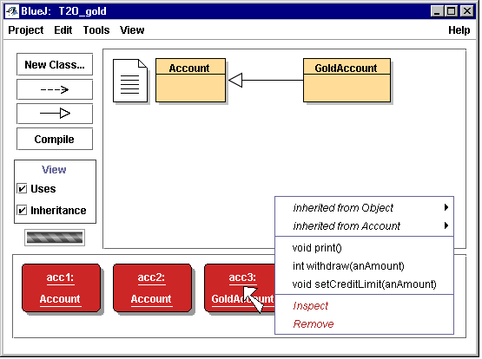
sub-menu for inherited methods

4. Use the initialise() method to set the owner for each account. Also deposit money into each account and set the creditLimit for each GoldAccount to an appropriate amount. Some sample data is shown below:-

acc1  “Jane”  deposit 100 | acc2  “George”  deposit 200 | acc3  “Fred”  deposit 50  credit limit 50 | acc4  “Sally”  deposit 150  credit limit 100

5. Use the print() method to display the status of each object.
C. Use the Object Inspector

1. Right Click on acc1 and inspect the values of the attributes for this object

2. Now inspect acc4

3. Notice the difference in the attributes displayed

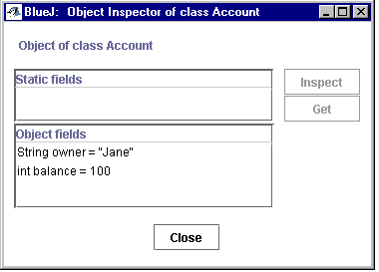 | 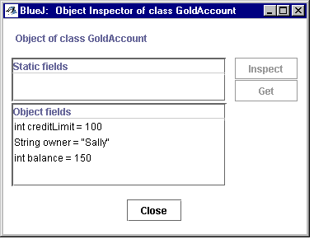

Exercises

1. Withdraw money in amounts of 25 from acc1 and acc3, how does their behaviour differ as you get down to a zero balance

2. Make one of the GoldAccounts become overdrawn and check that the owner cannot exceed the credit limit.

3. Add money to an overdrawn GoldAccount and check that it correctly reduces the overdraft.

4. What would you need to change if a 10% surcharge was made on every GoldAccount withdrawal that resulted in an overdraft?

