BlueJ is an Integrated Development Environment (IDE) for Java. It provides:-

a. An editor that allows you to create and modify Java programs.
b. A compiler that checks the program for syntax errors and creates runnable program code.
c. An environment to produce instances of classes and to invoke the methods of these classes and instances.
d. An object inspector that allows you to check the state of an object (see the values of its attributes)
e. A debugger that allows you to stop a runaway program or single step through parts of your program.

In this example we will use several of these features.

A. Create a new class

1. Start up BlueJ, wait until the message “Creating virtual machine … Done” appears in the bottom of the window.
2. From the menu, select Project: New enter the File name T2O_start
3. Click on the button New Class enter the Class name Account.
Ensure that the radio button for Class is selected
4. Right click the Account class icon and select Open Editor
5. Delete the existing code and replace it with the code shown opposite
(select the code, turn off the bullets, copy, then paste the code in BlueJ)
6. Press the Compile button to check your syntax and convert the program to a runnable form.
7. Once the program has been compiled successfully, select Class: Close from the menu to close the editor window.
8. If your class compiled correctly it will appear as a solid yellow colour; if has not been compiled it appears with diagonal bands (see below)
  Not compiled | 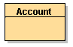  Compiled successfully
9. Only classes that have been compiled can be run. Each time you edit your class you will need to compile it again.


- public class Account
- {
- String owner;
- int balance;

- public Account()
- {
- } // end constructor Account()

- public void initialise(String name)
- {
- owner = name;
- balance = 0;
- } // end method initialise

- public void deposit (int anAmount)
- {
- balance = balance + anAmount;
- } // end method deposit

- public int withdraw (int anAmount)
- {
- int amountWithdrawn;

- if (anAmount <= balance)
- amountWithdrawn = anAmount;
- else
- amountWithdrawn = balance;

- balance = balance - amountWithdrawn;

- return amountWithdrawn;
- } // end method withdraw

- public void print()
- {
- System.out.println("Owner = "+ owner +" Balance = "+balance);
- } // end method print

- } // end class Account
B. Create instances of your class
You use the class as a template to create multiple example objects of your class. Each example object is called an instance and is created by running the constructor method for the class.

1. Right Click on the class Account and select new Account()
A dialogue box will appear, make the instance name account_1
2. In a similar way, create an instance of Account called account_2
The instances appear as red boxes near the bottom of the screen
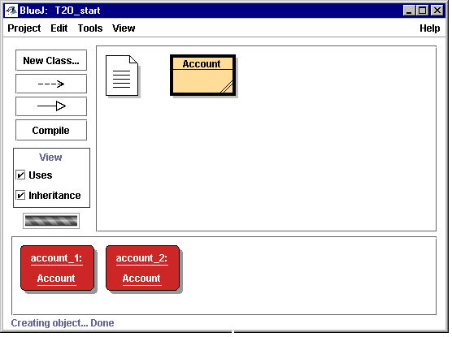
class
instance
3. Right Click on account_1 and select the initialise() method. A dialogue box will allow you to enter the parameter for the method. In this case it is the name of the owner, so type in “Jane” (you will need to type the inverted commas).
4. In a similar way, select the deposit() method of account_1 and deposit 100 into the account.
5. Now run the withdraw() method of account_1 and withdraw 50. This time a dialogue box will show the result returned by the method.
6. Repeat the above sequence for account_2. The owner is Fred and he deposits 200 into the account.

C. Use the Object Inspector to examine the state of an instance
The state of an object (instance) is determined by the values of its attributes.
In the case of these accounts, the attributes are owner and balance.

1. Right Click on account_1 and select inspect.  the object’s class  the object’s attributes and their current values | 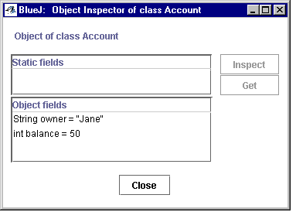

2. In the same way inspect the attributes of account_2
3. Run the withdraw() method of account_2 and withdraw 125
4. Inspect the attributes of account_2 and note the change in the balance
The methods, such as deposit() and withdraw() give the object behaviour and often change the state of the object by changing the values of its attributes.
5. Run the print() method of account_1. This method produces output in the BlueJ Terminal Window. (You may need to use View: Show Terminal to make the terminal window visible)

D. Exercises
Use the object inspector to examine the state of the object after each of the following actions:-
1. Create another account called account_3
2. Set the owner to be George
3. Deposit 50 into the account
4. Attempt to withdraw 75 from the account
5. Deposit 60 into account_2
6. Withdraw 20 from account_1

