In this exercise we will create a class to represent a point on a graph.

A point has a coordinates x and y, written as (x,y)

In the diagram below p1 is the point (1,3) and p2 the point (7,8):-

10
9
8  y |  |  |  |  |  |  |  |  | p2
7 |  |  |  | d
6
5
4
3 |  |  | p1
2
1
0 | 1 | 2 | 3 | 4 | 5 | 6 | 7 | 8 | 9 | 10
x coordinate

The distance between two points (d) is obtained by using Pythagoras’ Theorem.

In the class definition shown opposite:-

Lines 3,4: Define the attributes that store the x and y coordinates

Line 6: Defines a constructor for the class that allows the two coordinates to be initialised

Line 12: Defines a method add(aPoint) that allows two points to be added together. The format for the use of this method is p1.add(p2) and results in the x and y coordinates of p2 being added to the coordinates of p1.

Line 14: Shows how to access the x attribute of the parameter aPoint (aPoint.x)
The keyword this refers to the object that receives the message add(aPoint)

Line 17: Defines a method dist(aPoint) that calculates the distance between two points using Pythagoras’s Theorem.

Line 25: Defines a method toString( ) that converts the numeric x and y values into a text string in the form (x,y). This approach is more general that using a print() method which can only output to the terminal window.
- public class Point
- {
attributes x and y
hold coordinates of Point
- int x;
- int y;

- public Point(int xval, int yval)
- {
constructor uses these
two parameters to initialise the object
- x = xval;
- y = yval;
- } // end constructor Point(x,y)
this is the object receiving the message
- public void add(Point aPoint)
- {
- this.x = this.x + aPoint.x;
- this.y = this.y + aPoint.y;
aPoint is the parameter object
- } // end method add()

- public double distFrom(Point aPoint)
- {
- int xDiff, yDiff;
- xDiff = this.x - aPoint.x;
- yDiff = this.y - aPoint.y;
- return Math.sqrt( xDiff*xDiff + yDiff*yDiff);
- } // end method distFrom()

- public String toString()
- {
- return "("+x+","+y+")";
- } // end method toString

- } // end class Point

A. Create the Point class

1. Start BlueJ

2. Create a new project called T2O_Point

3. Create a new class called Point

4. Enter the code shown above

5. Compile the programs and check for syntax errors

(Exercises continue on the next page)
B. Use the constructor and other methods of the class Point

1. Right click on the class and use the constructor Point(x,y) to instantiate the following objects:-

p0  x=0, y=0 | p1  x=1, y=3 | p2  x=7, y =8 | p3  x=3, y=4

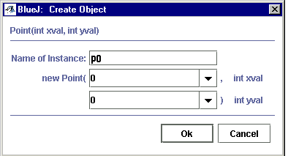

2. Use the object inspector to check on the state of objects p1 and p2

3. Invoke the method toString( ) for object p3. The return value is displayed in a dialogue box:-

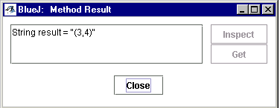

4. Invoke the method distFrom( ) for object p3. The dialogue box will prompt for a parameter of type Point – enter p0 as shown below. Note that you are sending the object reference to the method, not a value.

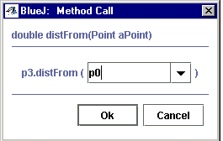

The result of invoking this method is the distance between points (3,4) and (0,0) which is 5.0

5. Send the message add(p2) to object p3. Use the method toString( ) to examine both p3 and p2.

6. Send the message distFrom(p3) to object p2.

Exercises

1. Add the following new method to class Point

- public boolean equalTo(Point aPoint)
- {
- if (this.x == aPoint.x & this.y == aPoint.y)
- return true;
- else return false;
- } // end method equalTo

This method tests if two points are equal (that is they have the same x and y values).

2. Instantiate three objects of class Point in order to test this method.

3. Write the code for a method that will subtract two points (use the add() method as a guideline). Create suitable objects with which to test your method.

